Chapter 1: Introduction
INTRODUCTION
Live streaming has become one of the most popular forms of digital communication, whether for gaming, education, events, or entertainment. However, managing multiple streaming elements—like switching between camera angles, playing media clips, adjusting audio, or inserting ads—often requires manual control within the OBS Studio interface. This can be challenging for streamers who are multitasking or operating solo.
OBS StreamPilot is designed to solve this problem. It is a remote controller application for OBS (Open Broadcaster Software) that allows users to control their entire live streaming setup from another device—like a phone, tablet, or laptop. The system connects to OBS through its WebSocket API, enabling real-time control over scenes, sources, and media playback remotely. This makes the streaming process smoother, more efficient, and highly flexible, especially for creators managing live sessions alone or from different locations.

  - PRESENT SYSTEM
At present, most streamers use OBS manually from the same PC that is running the stream. The user has to click through the OBS interface to switch scenes, control audio, or insert video clips. While OBS supports hotkeys, it still requires the person to be near the computer and focused on technical operations, which can interrupt the flow of live content.
Professional streamers sometimes use hardware stream decks, but these are expensive and not easily customizable. Free alternatives exist, but they often require complex setup processes, IP configurations, or third-party tools that are not user-friendly. This makes it difficult for small creators, educators, or casual streamers to manage multiple tasks during live streaming.
  - PROPOSED SYSTEM
The proposed system, OBS StreamPilot, is designed to act as a simple, smart, and wireless remote control for OBS Studio. It connects to OBS through the OBS WebSocket API, which allows external applications to send commands to OBS over a network.
The user simply opens the StreamPilot mobile application built using Flutter, connects to the OBS instance using the local IP and password, and gains full control of the stream. The system can perform various actions such as:
- Changing scenes or camera views,
- Playing or pausing preloaded media files,
- Controlling audio volume and mute states,
- Displaying live performance stats like CPU usage and stream time.
This system brings the power of OBS control into the user’s hands, literally allowing complete remote operation without touching the main PC during a stream.
1.3 OBJECTIVES
The main objectives of OBS StreamPilot are:
- To develop a remote controller system for OBS Studio using WebSocket communication.
- To provide a user-friendly web interface accessible from mobile or desktop browsers.
- To enable key controls such as scene switching, media playback, and audio control remotely.
- To improve the efficiency and convenience of managing live streaming setups.
- To design a low-cost, easily deployable solution that works on standard devices without extra hardware.

Chapter 2: System Design
2.1 Overview
The OBS StreamPilot system is designed to simplify and automate the process of controlling live streaming sessions. It provides a bridge between the user’s remote device (like a phone or laptop) and the main streaming computer running OBS (Open Broadcaster Software).
At the heart of this project lies the OBS WebSocket API, which allows external applications to communicate with OBS over a network. This API provides a variety of commands to perform actions such as switching scenes, starting or stopping the stream, controlling media sources, and adjusting audio levels — all in real time.
OBS StreamPilot utilizes this WebSocket connection to send these commands from a remote interface (a web or mobile dashboard). The user interacts with this interface to trigger actions, which are then transmitted to OBS instantly. The system is lightweight, flexible, and platform-independent, meaning it can work on any device with a browser and a stable network connection.
The main idea behind the design is to reduce manual effort during live streaming while maintaining full control over the broadcast. By separating the control interface from the main OBS setup, streamers can manage live scenes, add overlays, or play videos without interrupting their performance or presentation.

2.2 System Architecture
The architecture of OBS StreamPilot follows a modular client-server design, ensuring smooth communication between the controller interface and OBS Studio.
The architecture consists of the following components:
1. OBS Studio
This is the main broadcasting software responsible for live streaming and recording. It contains all the scenes, sources, and audio/video inputs. To enable remote control, the OBS WebSocket plugin is installed and configured with a secure port and password.
2. WebSocket Server
This is the communication link between OBS Studio and the remote controller. It receives commands from the frontend interface (e.g., “Switch Scene”, “Play Ad”) and sends them directly to OBS via WebSocket messages. This ensures real-time, two-way communication — if the user changes a scene, the OBS interface updates instantly.
3. Backend Server
- Developed using Python (Flask/FastAPI).
- Handles communication between the mobile app and OBS WebSocket.
- Processes commands like scene switching, audio control, and media playback.
- Sends responses back to the mobile application.
4. Mobile Application (Flutter)
- Built using Flutter framework
- Provides a responsive Android/iOS interface
- Displays:
- Scene buttons
- Audio sliders
- Media playback controls
- Live monitoring information
- Sends user commands to the backend through REST API or WebSocket
5. Communication Layer
- Enables continuous, two-way communication between OBS and StreamPilot.
- Ensures immediate response to user commands and updates the interface with real-time information (like current scene and CPU usage).
6. Monitoring & Feedback Module
This module constantly updates the dashboard with OBS’s live information (like active scene name, streaming status, and duration). It helps users confirm that each command was executed successfully.
2.3 System Flowchart
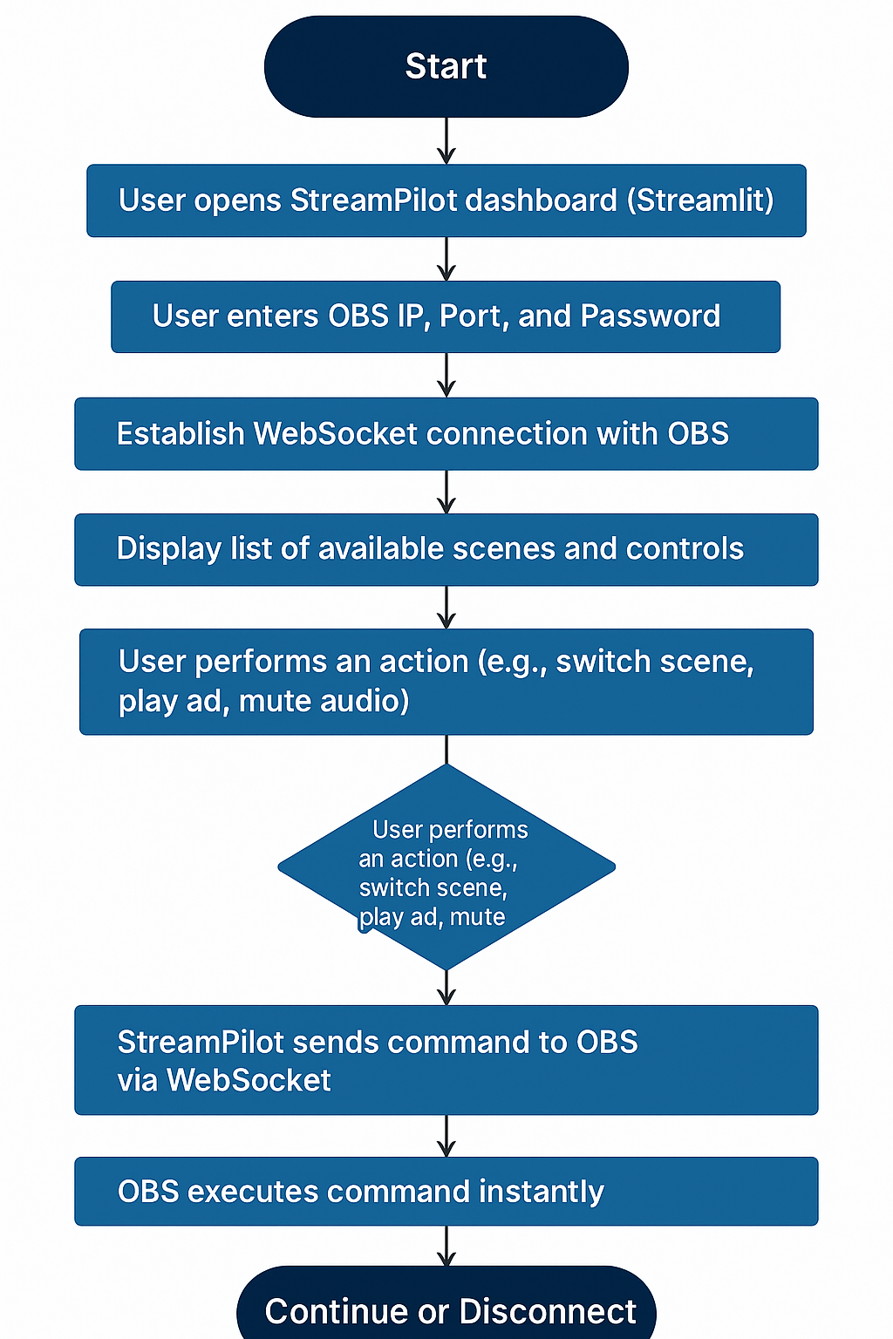
Figure 1: System Flowchart
2.4 Tools and Technologies
- Flutter (Dart): Used to develop the mobile application interface for Android and iOS devices.
- Python (3.10+): Core language for backend logic and WebSocket communication.
- OBS Studio: Main broadcasting software controlled by the system.
- OBS WebSocket Plugin (v5.0+): Enables remote communication between OBS and external applications.
- obswebsocket (Python library): Manages WebSocket requests and command execution.
- JSON: Used for structured data exchange between modules.
- REST API / WebSocket Communication: Enables real-time communication between the Flutter app and backend server.
2.5 Design Considerations
The design of OBS StreamPilot focuses on simplicity, responsiveness, and real-time functionality.
The following considerations were prioritized during development:
- Usability:
  - The interface must be clean, intuitive, and accessible to both beginners and professionals.
  - Streamlit ensures that users can control OBS with minimal setup.
- Performance:
  - Commands should execute instantly with minimal network delay.
  - WebSocket ensures low-latency, real-time control.
- Reliability:
  - The system must handle connection drops gracefully and maintain stability throughout live sessions.
  - Error handling and reconnection logic are implemented for robustness.
- Security:
  - Access is secured using the OBS WebSocket password.
  - Only authorized devices within the same network can connect.
- Scalability:
  - The modular design allows new features such as scene transitions, overlay control, or recording management to be added easily.
- Platform Independence:
  - Works on any device with a web browser (PC, tablet, or smartphone) without needing any installation beyond Python and Streamlit.

Chapter 3: Hardware and Software Details / Standards

3.1 Hardware Requirements
- Processor: Intel i5/i7 or equivalent AMD Ryzen
- RAM: Minimum 8 GB
- GPU (Optional): NVIDIA GTX 1050 or higher
- Storage: 500 GB SSD (recommended)
- Network: Stable Wi-Fi or LAN connection
- Camera (Optional): USB or IP camera for testing and scene switching

3.2 Software Requirements
- Flutter SDK (3.x or above) – Used for developing the mobile application interface.
- Dart Programming Language – Language used in Flutter development.
- Python (3.10+) – Used for backend development and WebSocket communication.
- Flask / FastAPI – Backend API server framework.
- OBS Studio (v29.0+) – Live streaming software controlled by the system.
- OBS WebSocket Plugin (v5.0+) – Enables remote communication between OBS and external applications.

3.3 Standards Followed
- Coding Standards: Python PEP-8, JavaScript ES6
- Communication Standards: WebSocket Protocol (RFC 6455)
- Security: Password-protected WebSocket connection
- Data Format: JSON for all data transfers

Chapter 4: Implementation Work Details
4.1 Real-Life Applications
The OBS StreamPilot project has wide-ranging applications in the growing field of live streaming, digital broadcasting, and remote media production. By allowing users to control OBS from any device over a network, it significantly simplifies live production workflows. Below are some key real-world applications of this system:
1. Online Education and Webinars
Teachers, trainers, and educational content creators often conduct live classes or webinars using OBS. With StreamPilot, they can remotely switch between lecture slides, camera views, and pre-recorded clips without interrupting the teaching flow. This ensures smoother transitions and a more engaging online learning experience.
2. Event Broadcasting and Stage Management
In live college events, cultural programs, or technical fests, managing the streaming setup can be challenging. OBS StreamPilot enables event managers to control scene transitions and play sponsor videos or announcements directly from a mobile device, even while standing away from the main streaming PC. This adds flexibility and helps maintain a professional-quality broadcast.
3. Podcasting and Live Shows
Podcasters and talk show hosts can use StreamPilot to switch between camera angles or add intro/outro clips during recording sessions. The ability to do this remotely enhances production quality and allows small teams to handle multi-camera setups efficiently.
4. Corporate Meetings and Online Conferences
Businesses that conduct online meetings or product launches can use StreamPilot to manage presentation overlays, speaker transitions, and promotional videos seamlessly. It allows the technical team to control the entire broadcast from another device, reducing clutter and saving time.
5. Gaming and Streaming Platforms
For gamers who stream on platforms like Twitch or YouTube Live, OBS StreamPilot acts as a mobile stream deck. It allows them to change overlays, switch camera feeds, or mute/unmute audio with one tap — all while staying focused on the gameplay.
6. Remote Production Studios
In large-scale setups or hybrid work environments, production teams can control OBS setups from different rooms or even remote locations. StreamPilot’s WebSocket-based control allows multiple authorized users to collaborate on a single live session, improving coordination and reducing setup delays.
7. College Media and Broadcasting Cells
For educational institutions, this tool is extremely useful in managing live event streaming, such as college festivals, orientation programs, or seminars. Students can handle transitions and ad placements from mobile devices, eliminating the need for expensive streaming hardware.
4.2 Data Implementation and Program Execution
The implementation of OBS StreamPilot involves several technical components that work together to establish remote control of OBS through WebSocket communication. Below is the step-by-step explanation of how the system is built and executed.
    - Connection and Authentication
- The user opens the StreamPilot Dashboard on any web browser (desktop or mobile).
- The dashboard asks for the IP address, port number, and password of the OBS instance.
- The connection is made through the OBS WebSocket Plugin, which acts as a gateway between OBS and external applications.
- Once authenticated, the user gains access to all available scenes, sources, and audio channels.
4.2.2 Scene and Source Control
- Once connected, the system retrieves a list of available scenes and displays them as buttons.
- When the user clicks a button (e.g., “Camera 1” or “Main Event”), StreamPilot sends a command to OBS via WebSocket to activate that scene.
- The change occurs instantly, with a visual confirmation displayed on the dashboard.
Example:
client.call(obswebsocket.requests.SetCurrentProgramScene("Main Camera"))
4.2.3 Media and Ad Playback
- The user can trigger media files (ads, intros, outros) stored in OBS’s “Media Source” list.
- StreamPilot sends commands to play or pause the selected media clip, then automatically returns to the previous live scene after playback.
Example Command:
client.call(obswebsocket.requests.SetMediaInputCursor("Ad_Clip", 0))
client.call(obswebsocket.requests.TriggerMediaInputAction("Ad_Clip", "restart"))
This feature is especially helpful in professional streams where ads or break videos must be played between live content.
4.2.4 Audio Control
- The dashboard provides real-time sliders to adjust volume and toggles to mute/unmute specific audio sources (e.g., mic or desktop audio).
- StreamPilot communicates these changes instantly using WebSocket commands.
Example Command:
client.call(obswebsocket.requests.SetInputMute("Mic/Aux", True)) # Mute mic
This ensures smooth and flexible control of sound levels during a live broadcast.
4.2.5 Monitoring and Feedback
- The dashboard constantly receives status updates from OBS (like the current scene, CPU usage, stream time, and recording state).
- These are displayed live, helping users track the stream health without touching the OBS PC.
Example Command:
status = client.call(obswebsocket.requests.GetStats())
print("Current FPS:", status.getStats()['fps'])
4.2.6 Storage and Logging (Optional)
- Each action performed (scene switch, ad play, mute, etc.) can be stored in a log file or database with timestamps.
- This helps in performance tracking or in generating reports for professional stream analytics.
4.2.7 Execution Workflow
- Start OBS Studio on the host machine and enable WebSocket server.
- Open StreamPilot dashboard on another device.
- Connect using IP, port, and password.
- The interface loads all scenes and controls.
- Execute actions (scene switch, ad play, mute/unmute).
- OBS performs each task in real time.

Chapter 5: Source Code

This chapter outlines the complete implementation of the OBS StreamPilot system using Python, Streamlit, and the OBS WebSocket API. The OBS StreamPilot system is implemented using a Flutter mobile application for the frontend and a Python-based backend server for OBS communication.

The Flutter application provides the graphical interface for users, while the backend server communicates with OBS Studio using the OBS WebSocket API.

5.1. Imported Libraries
from flask import Flask, request, jsonify
from obswebsocket import obsws, requests
import json
import time

Explanation:
- Flask – Creates API endpoints for communication with the Flutter app.
- obswebsocket – Sends commands to OBS Studio.
- json – Handles data exchange between backend and mobile app.
- time – Used for scheduling and delays.

5.2. Establishing WebSocket Connection
To start the system, StreamPilot connects to OBS Studio through its WebSocket server.
The connection requires the IP address, port number, and password that are configured in OBS (via the OBS WebSocket settings).
This connection forms the foundation of OBS StreamPilot. Once established, it allows Python to send commands to OBS instantly. The system displays a success message in the Streamlit interface to confirm the connection. If the connection fails, an error message is shown, allowing users to recheck the network or port configuration.

5.3. Scene Switching Function
The most important feature of StreamPilot is scene switching, which allows the user to change between scenes remotely with a single click.
The function sends a SetCurrentProgramScene() command through the WebSocket connection to change the active scene in OBS instantly. This allows smooth camera or layout transitions without requiring physical interaction with the streaming computer. The Streamlit interface updates immediately to reflect the change.

5.5 Playing Advertisements or Media Clips
OBS StreamPilot allows users to play preloaded ads or videos directly from the remote controller. This feature is implemented by sending a TriggerMediaInputAction command to OBS. Media files (such as ads, intros, or short videos) are added in OBS as “Media Sources.”
When the user triggers playback, StreamPilot sends a command to OBS to start that media source.
Once completed, OBS automatically returns to the previous live scene.
This feature is especially useful for event broadcasts or sponsored segments.
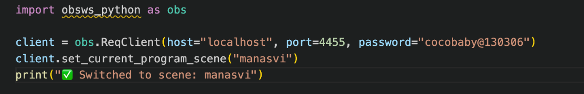
Figure 5.1: Scene Switching
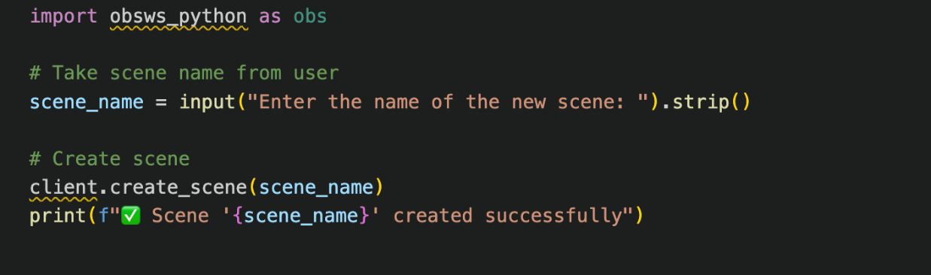
Figure 5.2: Creating a Scene
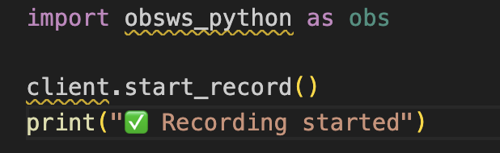
Figure 5.3: Starting the Recording

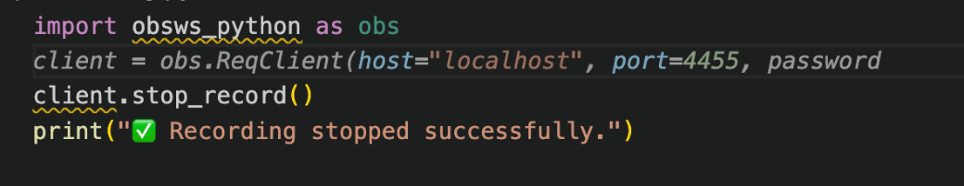
Figure 5.4: Stopping the Recording
Chapter 6: Input/Output Screens
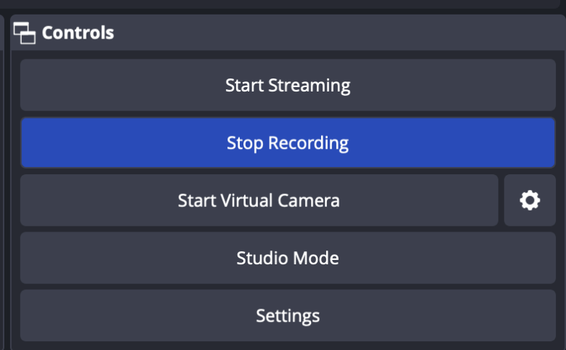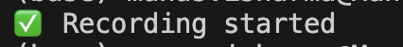
Figure 6.1: Recording start
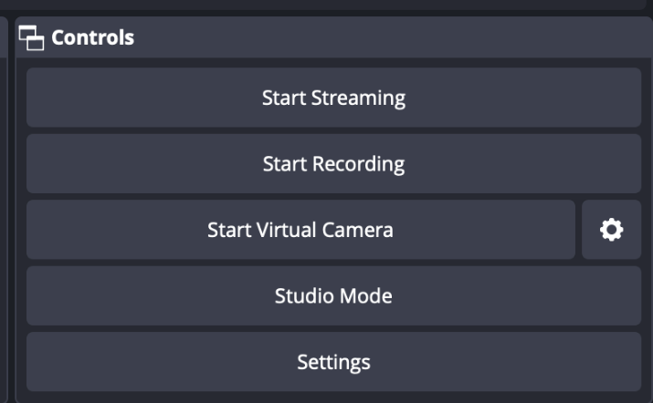
Figure 6.2: Recording stopped
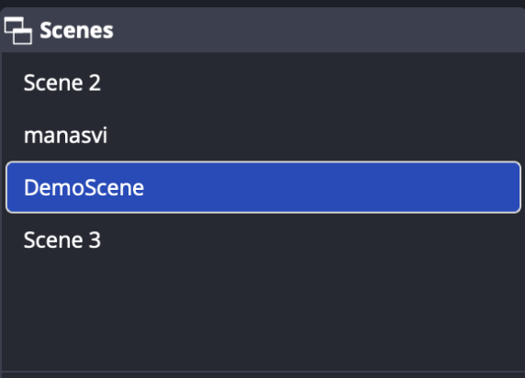
Figure 6.3: Scene created

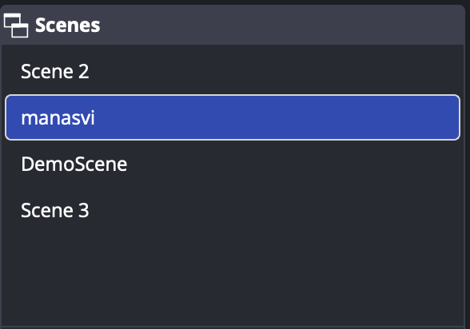
Figure 6.4: Detected Number Plates with their text conversion

Chapter 7: System Testing

System testing is a crucial phase in the software development lifecycle. It ensures that all integrated modules of the OBS StreamPilot application work together correctly and achieve the intended objectives.
In this project, several testing techniques, including unit testing, functional testing, interface testing, and performance testing, were carried out to verify the system’s reliability, stability, and accuracy.
The testing phase focused on validating the WebSocket communication, Streamlit interface responsiveness, and the real-time synchronization between the remote controller and OBS Studio.
7.1 Testing Methodology
• Unit Testing: Individual components of the system were tested to ensure proper functionality. This included establishing and disconnecting WebSocket connections, executing single commands like Switch Scene or Play Media, and validating OBS responses. Each function was verified using test cases to confirm correct command execution without errors.
• Functional Testing: The complete workflow of the system was tested, including connecting to OBS, switching scenes, controlling audio, and playing ads remotely. All actions were verified visually in OBS Studio to confirm real-time synchronization and accurate execution.
• Interface Testing: The Streamlit-based interface was tested for responsiveness across devices, correct display of scene lists and buttons, and proper input validation for IP, port, and source names. Error handling was also tested to ensure a smooth and user-friendly experience.
• Performance Testing: Performance evaluation focused on connection stability, command response time, and dashboard update speed. Average latency between user command and OBS response was found to be under 100 milliseconds, ensuring smooth, real-time remote control.
7.2 Observations
- The system established stable WebSocket connections consistently under normal network conditions.
- Commands like scene switching and media playback were executed instantly with negligible delay.
- The Streamlit dashboard performed smoothly and updated the OBS status in real time.
- Performance slightly degraded on weak or unstable Wi-Fi connections but quickly recovered after reconnection.
- No application crashes or freezes were observed during long-duration test sessions.
- Overall, the system showed high reliability and accuracy in executing remote commands.

7.3 Bug Handling and Fixes
During the testing phase, a few issues were identified and resolved:
- Connection Timeout Error:
Occasionally, the WebSocket connection timed out if OBS was restarted.
→ Fix: Added automatic reconnection logic and error handling to detect disconnections and reinitialize the connection smoothly.
- Unresponsive Buttons:
Streamlit buttons sometimes failed to respond when the page reloaded.
→ Fix: Implemented session states in Streamlit to maintain button state and prevent duplicate function triggers.
- Invalid Input Handling:
Entering incorrect IP address or port caused script errors.
→ Fix: Added input validation and error messages to guide users to re-enter valid connection details.
- Delayed Status Update:
The monitoring panel initially showed outdated OBS statistics.
→ Fix: Introduced a timed refresh function to fetch live stats every few seconds.
After these fixes, the system achieved stable and consistent performance across all tested environments.

Chapter 8: Individual Contribution
Palak Sharma
I was responsible for the integration of all modules and the preparation of the project documentation. My main task was to integrate the frontend interface with the backend functionalities to develop a fully functional system. I ensured smooth communication and coordination between the user interface and backend logic. I also prepared all project-related documents, including the final report, technical write-up, and user manual. Additionally, I recorded the testing results, implementation details, and assisted in final verification to make sure the project met all required specifications before submission.

Manasvi Sharma
I handled the backend development and testing of the project. My role involved developing the core functionalities of the system such as starting and stopping streaming, switching scenes, and controlling recording features in OBS Studio. I wrote and managed the Python code for backend logic and WebSocket-based event handling. I also conducted unit testing, debugging, and performance checks to ensure stability and smooth operation. Throughout the development, I maintained the logical structure of the program and collaborated with the frontend and integration teams to ensure seamless functionality.

Pragya Bhartiya
I was responsible for the frontend development of the OBS StreamPilot mobile application using Flutter. I designed and implemented the user interface, including scene control buttons, audio sliders, and media playback controls. I ensured the application was responsive and easy to use on mobile devices. I also integrated the Flutter app with the backend API to enable real-time communication with OBS Studio and performed usability testing to improve the interface design.
Chapter 9: Conclusion
The OBS StreamPilot system developed in this project successfully demonstrates the integration of Python, Streamlit, and WebSocket communication to solve a practical problem — remotely controlling Open Broadcaster Software (OBS) during live streaming. By leveraging the OBS WebSocket API, the project provides a real-time, responsive, and user-friendly remote controller that simplifies stream management tasks such as switching scenes, playing ads, and controlling audio.
The system allows users to operate OBS from any device connected to the same network, providing greater flexibility and efficiency during live broadcasts. Through this project, the feasibility of building a lightweight, cost-effective, and scalable remote streaming assistant has been successfully demonstrated.
The system performs the core functions of:
- Establishing a WebSocket connection between Python and OBS.
- Allowing remote scene switching and media playback.
- Providing real-time audio controls and monitoring capabilities.
- Delivering a clean, intuitive, and interactive Streamlit-based interface for users.
Overall, the project has shown that automation and remote control in broadcasting can be achieved effectively using open-source technologies, reducing dependency on expensive hardware like stream decks or controllers.
9.1 Limitations
Despite the successful implementation, a few limitations were observed during development and testing:
- Local Network Restriction: The system currently works only within the same local network (LAN or Wi-Fi) and cannot control OBS over the internet without additional configuration.
- Limited Error Handling: Connection interruptions due to unstable Wi-Fi may require manual reconnection in some cases.
- Basic Interface Controls: The Streamlit dashboard supports only core actions (scene switch, media, and audio control) and lacks advanced features like transitions, overlays, or automation sequences.
- No Cloud Synchronization: The system operates as a standalone controller without cloud-based user management or analytics.
- Single-User Operation: Only one user can control OBS at a time; multi-user collaboration is not yet supported.
9.2 Scope for Future Work
Several enhancements can be explored to extend the system’s functionality and real-world usability in future versions:
- Remote (Cloud-Based) Access: Enable OBS control from anywhere over the internet by integrating secure tunneling or cloud-hosted APIs.
- Mobile Application Development: Enhance the Flutter mobile application with additional features such as preview thumbnails, customizable control panels, and advanced automation tools.
- Enhanced UI/UX: Add features such as custom shortcuts, real-time preview thumbnails, and dark mode for improved user experience.
- Automation and Scheduling: Implement event triggers or automated scene changes (e.g., time-based transitions, motion detection).
- Database Integration: Store user actions, ads played, and session logs in a database (SQLite or Firebase) for analytics and reporting.
- Security Improvements: Add authentication, encryption, and user role management to ensure safe access over shared networks.
- Cross-Network Deployment: Enable communication between devices on different networks using tunneling, VPN, or OBS WebRTC extensions.

Chapter 10: Bibliography
[1] OBS Studio, Open Broadcaster Software (OBS). [Online]. Available: https://obsproject.com/
[2] OBS WebSocket, OBS WebSocket Plugin Documentation, GitHub Repository. [Online]. Available: https://github.com/obsproject/obs-websocket
[3] Streamlit Inc., Streamlit — The fastest way to build data apps in Python. [Online]. Available: https://streamlit.io/
[4] Python Software Foundation, Python Programming Language — Version 3.10 Documentation. [Online]. Available: https://docs.python.org/3.10/
[5] OBS WebSocket Python Library, obs-websocket-py: Python client for OBS WebSocket API. [Online]. Available: https://github.com/Elektordi/obs-websocket-py
[6] The JSON Data Interchange Standard, Introducing JSON — ECMA-404 Standard. [Online]. Available: https://www.ecma-international.org/publications-and-standards/standards/ecma-404/
[7] T. O’Hara, “WebSocket: Lightweight Client-Server Communication for Real-Time Applications,” IEEE Internet Computing, vol. 22, no. 5, pp. 72–79, Sept.–Oct. 2018.
[8] Streamlit Community Forum, Building Real-Time Web Apps with Streamlit and Python WebSocket Libraries. [Online]. Available: https://discuss.streamlit.io/
[9] Visual Studio Code, Integrated Development Environment by Microsoft. [Online]. Available: https://code.visualstudio.com/
[10] Flask Documentation, Flask Web Framework — Lightweight Python Web Apps. [Online]. Available: https://flask.palletsprojects.com/

Chapter 11: Annexures

